# Introduction of EtherCAT Implementation with LAN9252

Device featured: Microchip DEVB-LAN9252-SPI

The SPI bit lanes are supported with a clock rate up to 80MHz

The following is the system block diagram from (Microchip), taking into account that the Microcontroller will be the Nucleo-F446ZE and the EtherCAT Master will be a PLC/IPC from Beckhoff.

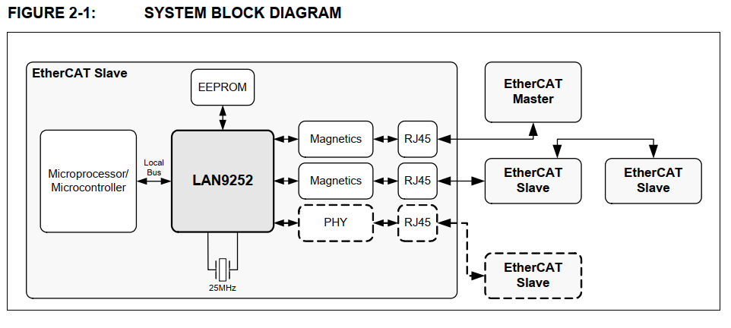

The Internal diagram of the chip:

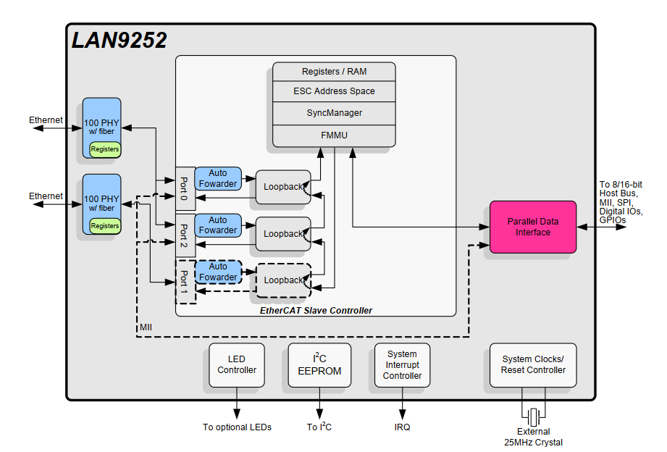

The following is the operation mode in which an external microcontroller uses a SPI or Quad-SPI to communicate and control the EtherCAT Slave.

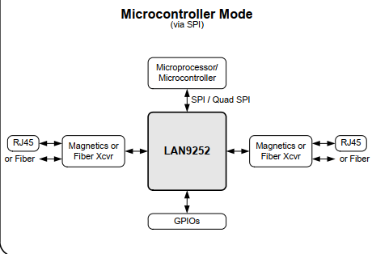

Regarding the implementation of the Protocol Stack

It might be possible that a licensed stack is needed such that the device can be certified as official compatible EtherCAT device.

<https://www.ethercat.org/en/products/54FA3235E29643BC805BDD807DF199DE.htm>

## Set of instructions for LAN9252 (SPI Mode)

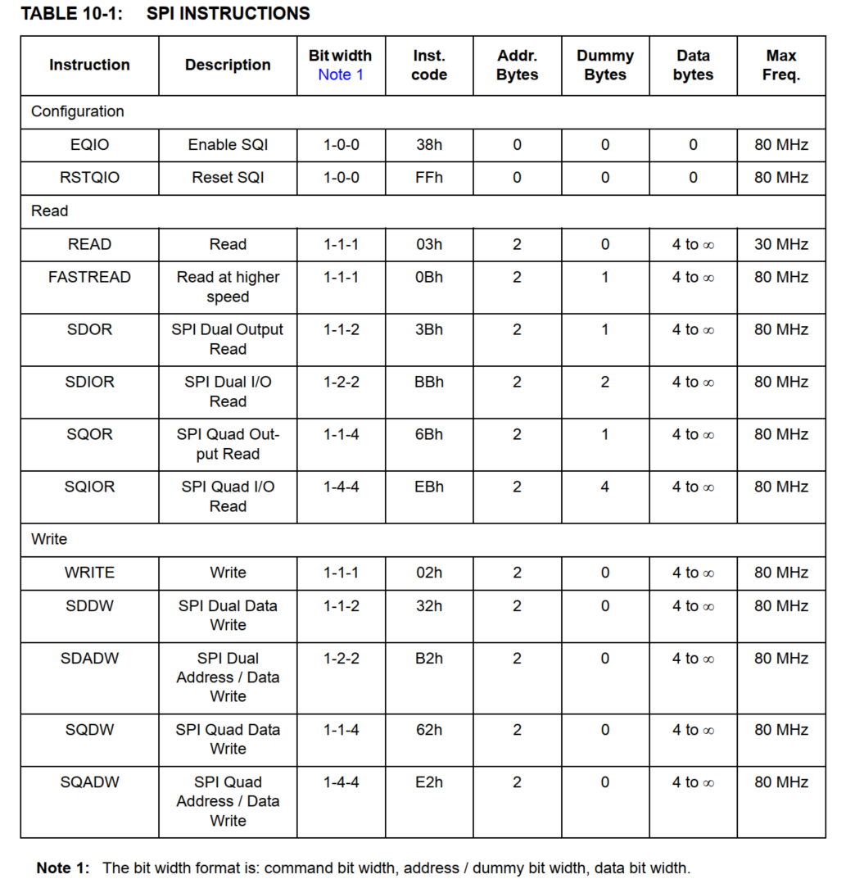

## Status and Control Registers

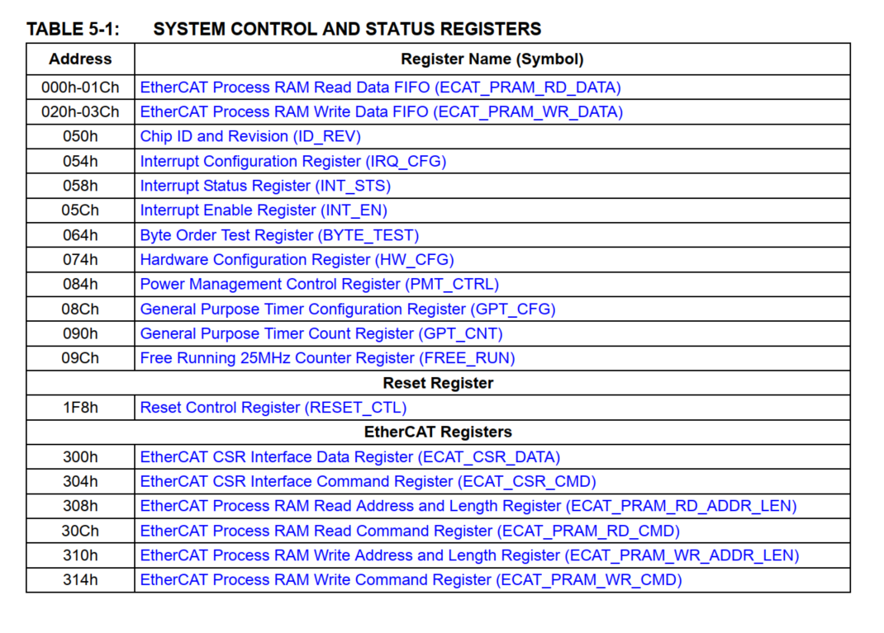

## First communication tests over SPI

Data to be sent is 0x0b 0x00 0x64

With a clock with a prescaler of 8

Those are errors in the channel

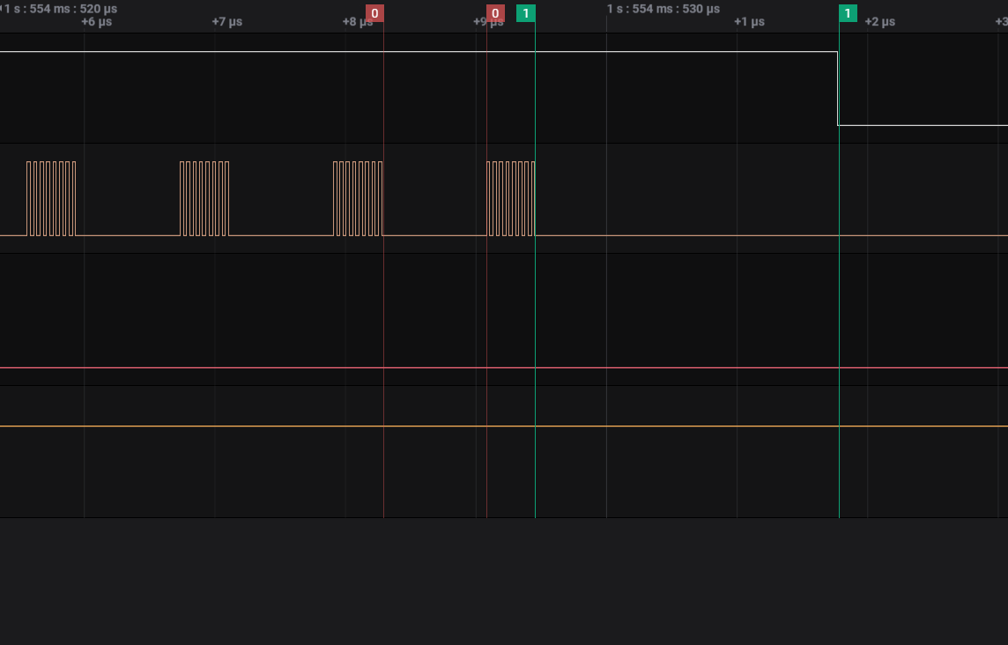

0 is the time between send instructions, even if they are executed with the library HAL_SPI_TransmitIT();

788 ns

6.25 ns cpu clock

1Is the period of time that the interrupt needs to be executed (first instruction)

2.33us

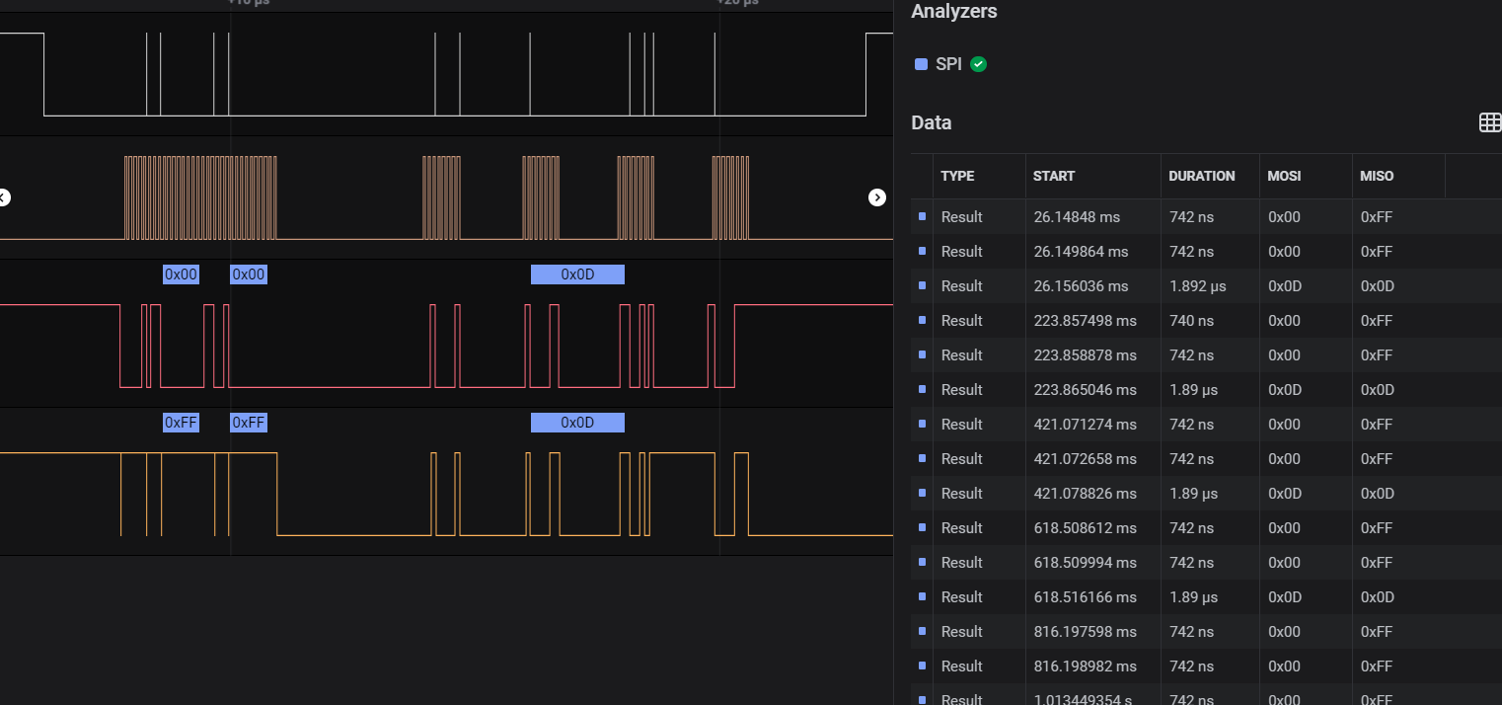

SPI with DMA

The following pictures shows the delay introduced by interruption handling: marker 1 is the delay until Half Buffer has been sent interruption, as for marker 2 corresponds the Full Buffer Interruption.

1.Half-Completed Transmission

2.59 us

2.Full-Completed Transmission

4.53us

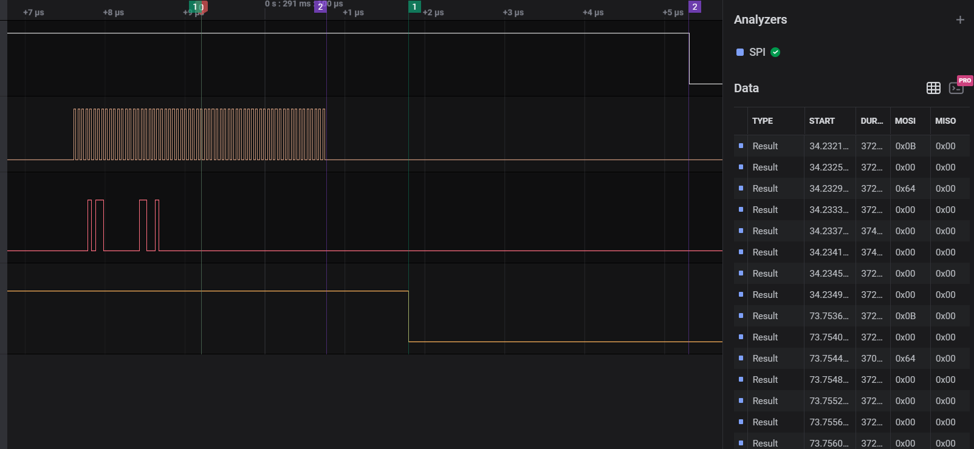

SPI with DMA (only transmit instruction since the transmit receive one is getting lost)

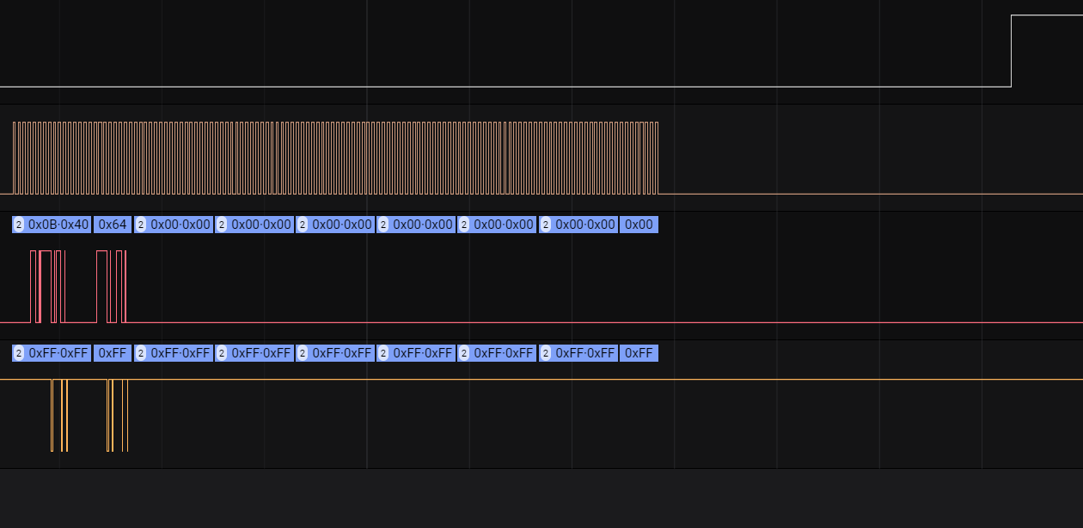

The following is a right reading procedure of the BYTE_TEST, the result is coming in Little Endian format.

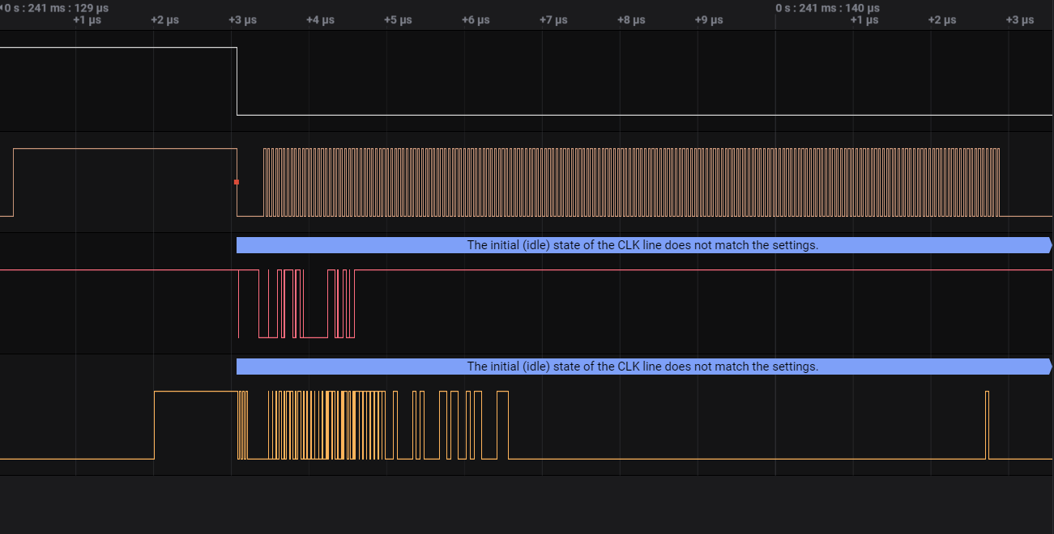

# Design of the EtherCAT Slave Controller

## Preliminars

The application process data which will be the description for the Fieldbus of the data that is going to be transmitted is based on three different files:

* ESI
* SII-EEPROM
* CoE Object Dictionary (matrix for complex devices)

The ESI and SII-EEPROM files can be kept as small as possible to pass the CTT -Compliance Test for EtherCAT devices-. Optional Data (OD) will be stored in the Device itself and transmitted with CoE.

NOTE: The Device will assume a Slave Device with fixed PDO and OD data.

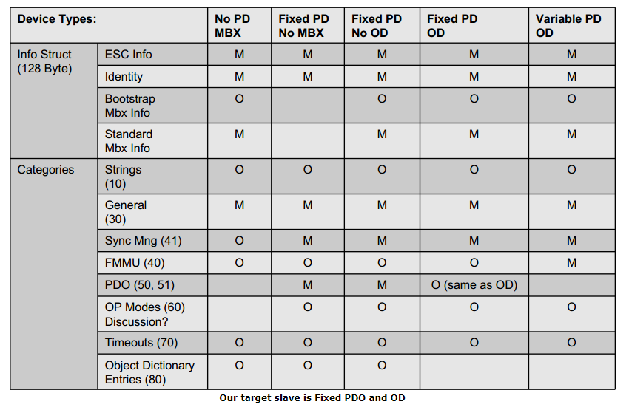

Figure From SOES example

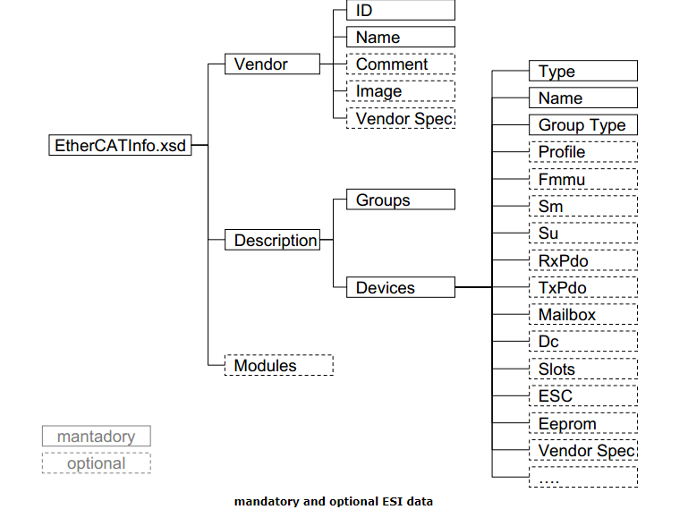

Figure ESI data that is mandatory